**Ch 4 - The Logic of Boolean Connectives**

**Tautologies and Logical Truth**

* A sentence S is a **logical consequence** of a set of premises P1,...,Pn if it is impossible for the premises to all be true while the conclusion is false
* There are some sentences that are always true. Therefore, no matter what premises you start out with, the sentence will be true, including always when the premises are true.
* Such **logically necessary** sentences are called **logical truths**

Some true claims are necessarily true but other claims aren’t necessarily true, they just happen to be true.

**Necessary sentences can’t be truth functional**

* if we view “necessary” as a sort of connective, it isn’t truth functional.
* in a world where A is a cube, “A is necessarily a cube” is false, but A is

**Vague Definitions**

**logically possible claim:** a claim is logically possible if it could be (or could have been) true, at least on logical grounds. By "logical grounds" is meant "that satisfies basic logical axioms."

For example, it is logically possible for a spaceship to travel faster than the speed of light. It is not physically possible, but there is no logical axiom that is broken by something traveling faster than the speed of light.

An object not being identical to itself is not, however, logically possible. This would violate the meaning of identity, which is part of some basic axiom of logic.

Another way to think about a claim being logically possible is: a claim is logically possible if there is some circumstance (or situation or world) in which the claim is true, and this circumstance or situation obeys basic fundamental logic axioms.

Next we have the terms **logical truth** and **logical necessity**. As far as I understand these are the same thing. A claim is a logical truth aka logical necessity if it is true in every logically possible circumstance or situation; it is a sentence which cannot be false under logical axioms.

Consider the (atomic) sentence a=a. If we build a truth table for this atomic sentence, it has two rows, one for T and one for T.

By the definition of tautology, this is not a tautology: the sentence is not true for every possible truth value of its constituents (and note that there is only one constituent, the sentence itself).

However, it is not logically possible for a=a. Therefore, despite not being a tautology, a=a is a logical truth, aka a logical necessity.

“You can’t build such a world with Tarski’s World, but that is not logic’s fault, just as it’s not logic’s fault that you can’t travel faster than the speed of light. Tarski’s World has its non-logical laws and constraints just like the physical world.”

**Tautology**

* simple kind of logical truth
* A & ~A as a principle is known as the **law of the excluded middle**, and every instance of this principle is a tautology

If the only thing that matters is the connectives and the structure of the sentence, then in any world, those things are going to be the same. The meaning of “or” is always going to be “or”, and the meaning of negation is always going to be negation, in any logically possible situation, and so any tautology is going to turn out to be a logical truth.

A logical truth is a logical consequence of any set of premises.

Also, a logical truth is a logical consequence of no premises at all.

**a=a is not a tautology.** It is just an atomic sentence. A truth table for this atomic sentence would just have a T and an F. It is logically impossible for a=a to be false however, and so it is a logical necessity.

Note that the fact that it is logically impossible for it to be false is not due to the functional connectives (there aren’t any in a=a); this is reflected in the fact that we don’t get a tautology if we construct a truth table for a=a.

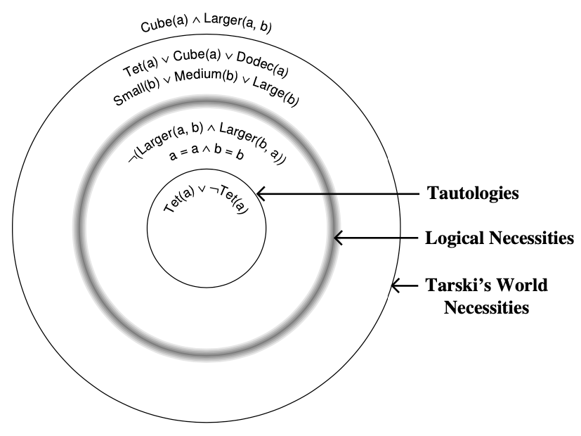

**Tautological Equivalence**

* two sentences are tautologically equivalent if they can be seen to be equivalent simply in virtue of the meanings of the truth-functional connectives
* we check using truth tables

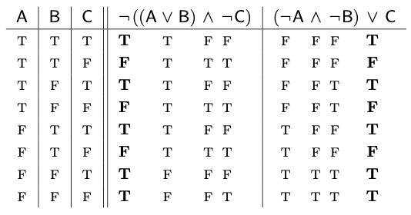

* all tautologically equivalent sentences are logically equivalent, but the reverse does not in general hold
* tautological equivalence is a strict form of logical equivalence, one that won’t apply to some logically equivalent pairs of sentences

**An important point about a limitation of truth tables**

* truth tables are sensitive only to the meanings of the truth-functional connectives
* they don’t detect situations (combinations of truth values) that are not logically possible
* for example
  + a=b & Cube(a)
  + a=b & Cube(b)
* it is not logically possible for Cube(a) to be true and Cube(b) to be false or vice-versa, because this would violate some basic law of logic; if the first sentence is true and the second false, we reach the conclusion that Cube(a) is both true and false, for example.
* It is possible to prove that the two sentences have the same truth value in any logically possible circumstance; therefore the two sentences are **logically equivalent**; but since the truth tables aren’t exactly the same, they are not tautologically equivalent

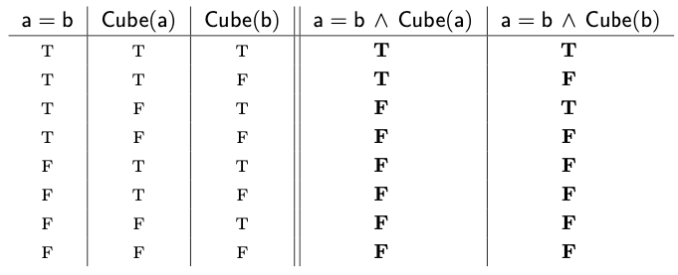

We are mainly interested in the **logical consequence** relation.

**Logical truth** and **logical equivalence** are special cases of logical consequence.

**Logical truth:** sentence that is a logical consequence of any set of premises

**Logically equivalent sentences:** sentences that are logical consequences of one another

* statements p and q are logically equivalent if they are provable from each other under a set of axioms, or have the same truth value in every model

**Tautological consequence** is a strict form of logical consequence

A **tautology** is a **strict form** of **logical truth (necessity).**

* there are logical truths that are not tautologies.

**Tautological equivalence** is a **strict form** of **logical equivalence**

* as in the example above, there are logical equivalences that are not tautological equivalences.

**Tautological consequence** is a **strict form** of **logical consequence**

* consider two sentences P and Q
* build their joint truth table
* to know whether Q is a tautological consequence of P, check the rows where P is true; if Q is true in all these rows, then Q is a tautological consequence of P: if P is true then Q must be true as well, and this holds due simply to the meanings of the truth-functional connectives
* any tautological consequence Q of P must also be a logical consequence of P

Truth tables allow us to define a precise notion of tautological consequence, a strict form of logical consequence, just as they allowed us to define tautologies and tautological equivalence, strict forms of logical truth and logical equivalence.

**Recap of terms**

**logical consequence:** a sentence S is a **logical consequence** of a set of premises P1,...,Pn if it is impossible for the premises to all be true while the conclusion is false

**logically possible claim:** a claim is logically possible if it could be (or could have been) true, at least on logical grounds. By "logical grounds" is meant "that satisfies basic logical axioms."

**logical truth (logical necessity):** sentence that is logical consequence of any set of premises; ie a sentence that is true in all logically possible circumstances; such a sentence can be false in a truth-table sense, ie due simply to the connectives involved; but when we consider logical axioms, some of the combinations in the truth table are not logically possible

**tautology:** sentence that is always true, even in logically impossible circumstances; true for all rows in a truth table

**logical equivalence:** sentences that are logical consequences of one another are logically equivalent sentences; they are provable from one another under a set of axioms

**tautological equivalence:** if two sentences have the same truth values for all combinations of atomic sentences, they are tautologically equivalent; note that some of the combinations may be logically impossible. This is why this form of equivalence is stricter than logical equivalence: two sentences may share truth values in all logically possible circumstances but not logically impossible circumstances; they would thus be logically but not tautologically equivalent.

* we’re using the precise concept of tautological equivalence to model the imprecise notion of logical equivalence
* if the truth table methods tells us that the formulae are tautologically equivalent, then we know that they must be logically equivalent. But if the sentences are not tautologically equivalent, then we have to do some more work to decide whether or not the’re logically equivalent.

**tautological consequence:** concept defined in a truth-table sense:

a = “Socrates is a man”

b = “All men are mortal”

c = “Socrates is mortal”

a & b

∴ c

It is logically impossible for the premise to be true while the conclusion is false.

However, if we write out a joint truth table for the premise and conclusion, we can find a row where a & b is true and c is false. This is simply due to the connectives and their meaning.

**negation normal form of sentences**

* using only the two DeMorgan laws and double negation, we can take any sentence built up with &, |, and ~, and transform it into one where ~ applies only to atomic sentences
* in other words, any sentence built out of atomic sentences using the three connectives &, |, and ~ is logically equivalent to one built from literals using just & and |
* the transformed sentence is said to be in NNF
* a sentence is a **literal** if it is either atomic or the negation of an atomic sentence

**iff symbol**

* not itself a symbol of the FOL, but a shorthand way of saying that two sentences are logically equivalent

**chain of equivalences**

* a demonstration where we start with a sentence and we substitute logical equivalents of pieces of the sentence to arrive at a logically equivalent sentence

**& distributes over |**

* P & (Q | R) is logically equivalent to (P & Q) | (P & R)
  + this is similar to the notion that multiplication distributes over addition
* addition does not distribute over multiplication, but | does distribute over &
* P | (Q & R) is logically equivalent to (P | Q) & (P | R)
* the distributive law of x over + allows us to transform any algebraic expression involving + and x, no matter how complex, into one that is just a sum of products
* similarly, the distribution of & over | allows us to transform any sentence built up from literals by means of & and | into a logically equivalent sentence that is a disjunction of one or more conjunctions of one or more literals
  + a sentence in this form is said to be in **disjunctive normal form (DNF)**

**example**

(A | B) & (C | D)

iff [(A | B) & C] | [(A | B) & D]

iff (A & C) | (B & C) | [(A | B) & D]

iff (A & C) | (B & C) | [(A & D) | (B & D)]

iff (A & C) | (B & C) | (A & D) | (B & D) **(DNF)**

* distribution of & over | lets us drive conjunction signs deeper and deeper, just like DeMorgan laws allow us to move negations deeper
* thus if we take any sentence and first use DeMorgan (and double negation) to get a sentence in NNF, we can then use this first distribution law to get a sentence in DNF
* we can also use the distribution of | over & to turn any negation normal form sentence into one that is a conjunction of one or more sentences, each of which is a disjunction of one or more literals.
* such a sentence is in **conjunctive normal form (CNF)**

**example**

(A & B) | (C & D)

iff [(A & B) | C] & [(A & B) | D]

iff [(A | C) & (B | C)] & [(A | D) & (B | D)]

iff (A | C) & (B | C) & (A | D) & (B | D)